2-Setup your github

- Download GitHub Desktop from https://desktop.github.com
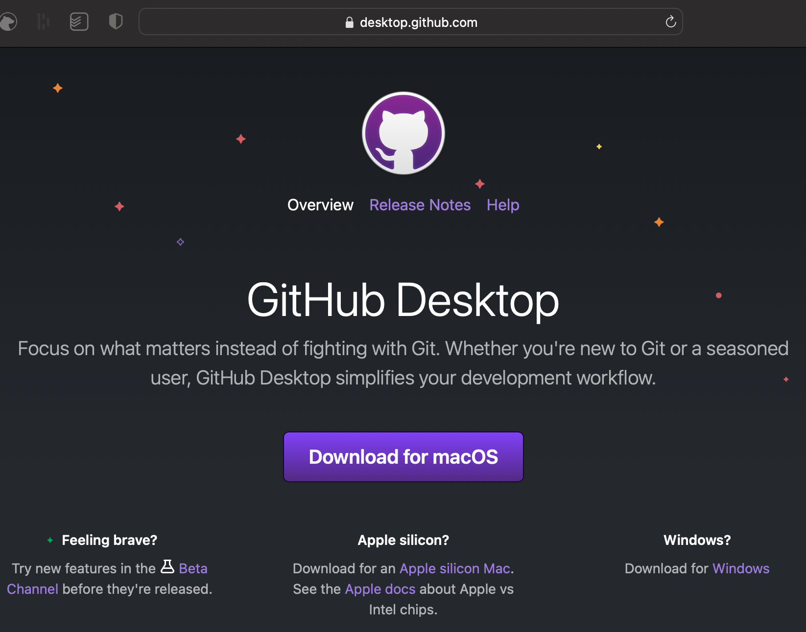

  - Leave it… for now…

- Go to GitHub.com and create an account with your RPI email

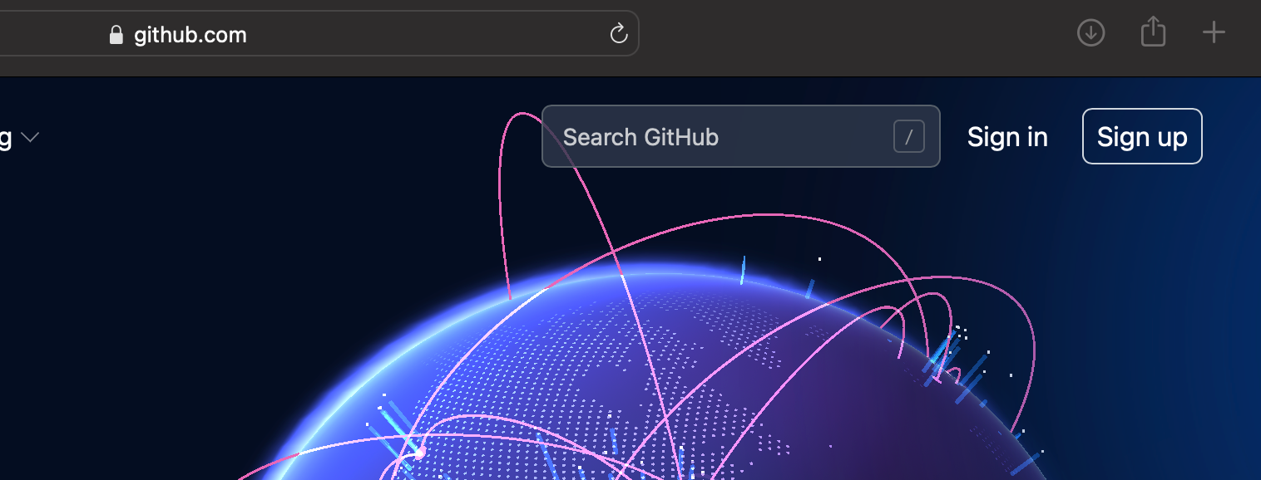

  - If you already have an account on GitHub, go to your profile and add your rpi email

- Send your GitHub id, RPI email address to kcs@rpi.edu and to me rplotka@rpi.edu
  - We will add you to the ITWS1100 Team on GitHub

- Take a screenshot of your profile page

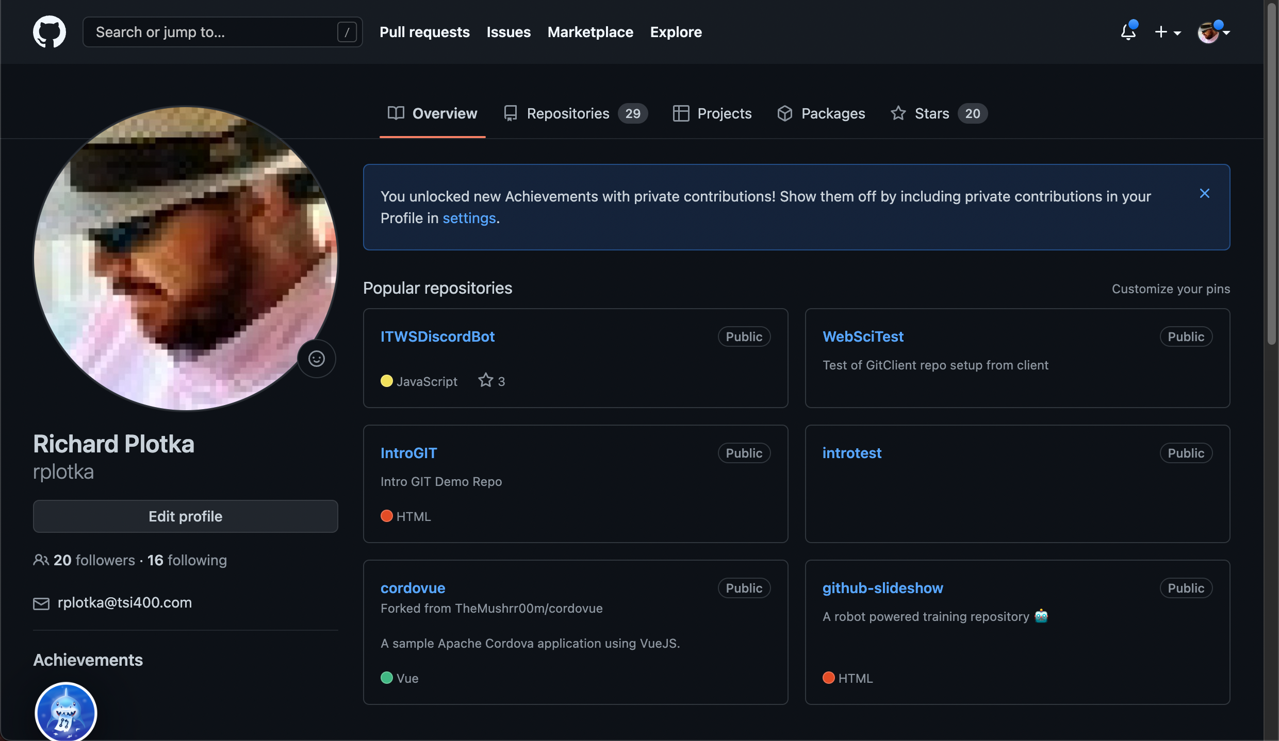

- That’s it for now

